**Program no.1:-**

#include<stdio.h>

#include<conio.h>

int main (){

    int num1 , num2;

    printf("Enter the two number's : ");

    scanf("%d %d", &num1 , &num2);

    printf("The sum of two given number is : %d \n" ,num1+num2 );

    printf("The subtraction of two given number is : %d \n" ,num1-num2 );

    printf("The multiplication of two given number is : %d \n" ,num1*num2 );

    return 0 ;

}

**Output:-**

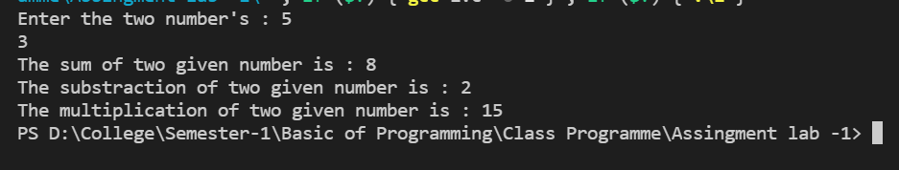

**Program no.2:-**

#include<stdio.h>

#include<conio.h>

#include<math.h>

int main(){

    int radius_circle ;

    float area , perimetre;

    // Area and perimeter of Circle

    printf("Enter the value of radius : \n");

    scanf("%d",&radius_circle);

    area = 3.14*radius_circle*radius_circle;

    printf("The value of area of circle : %f \n" , area);

    perimetre = 2*3.14*radius_circle;

    printf("The value of perimeter of circle : %f \n" , perimetre);

    printf("\n");

    // Area and perimeter of Triangle

    int side1_triangle,side2_triangle,side3_triangle  , s;

    printf("Enter the value of 3 sides of triangle  : \n");

    scanf("%d %d %d",&side1_triangle , &side2_triangle , &side3_triangle);

    s= (side1_triangle+side2_triangle+side3_triangle)/2;

    area= sqrt((s*(s-side1_triangle)*(s-side2_triangle)*(s-side3_triangle)));

    printf("The value of area of triangle : %f \n" , area);

    perimetre=side1_triangle+side2_triangle+side3_triangle;

    printf("The value of perimeter of triangle is  : %f \n" , perimetre);

    printf("\n");

    // Area and perimeter of Rectangle

    int lenght_rectangle , breadth_rectangle;

    printf("Enter the value of lenght and breath of rectangle : \n");

    scanf("%d %d",&lenght_rectangle , &breadth_rectangle);

    area = lenght_rectangle*breadth_rectangle;

    printf("The value of area of rectangle : %f \n" , area);

    perimetre=2*(lenght_rectangle+breadth_rectangle);

    printf("The value of perimeter of rectangle is  : %f \n" , perimetre);

    printf("\n");

    // Area and perimeter of square

     int side_square;

    printf("Enter the value of side of square : \n");

    scanf("%d ", &side_square);

    area = side_square*side_square;

    printf("The value of area of square : %f \n" , area);

    perimetre=4*side_square;

    printf("The value of perimeter of rectangle is  : %f \n" , perimetre);

    return 0 ;

}

**Output:-**

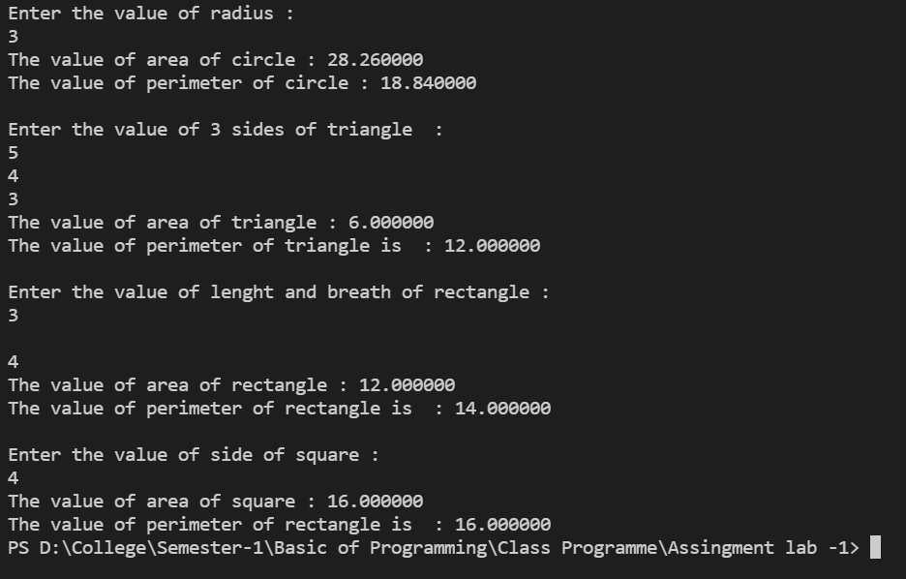

**Program no.3:-**

#include<stdio.h>

#include<conio.h>

int main(){

    int principal , rate , time ;

    float si ;

    printf("Enter the value of principal : ");

    scanf("%d",&principal);

    printf("Enter the value of rate : ");

    scanf("%d",&rate);

    printf("Enter the time : ");

    scanf("%d",&time);

    si = (principal*rate*time)/100;

    printf("The value of Simple interest is  : %f", si);

    return 0 ;

}

**Output:-**

